**HAMM-3R texts**

**INTRO SCREEN**

**HAMM-3R (2025)**

>> PRESS ANY BUTTON TO START <<

[ESC] TO PAUSE / INFO

**PAUSE SCREEN**

>> [ESC] TO GO BACK <<

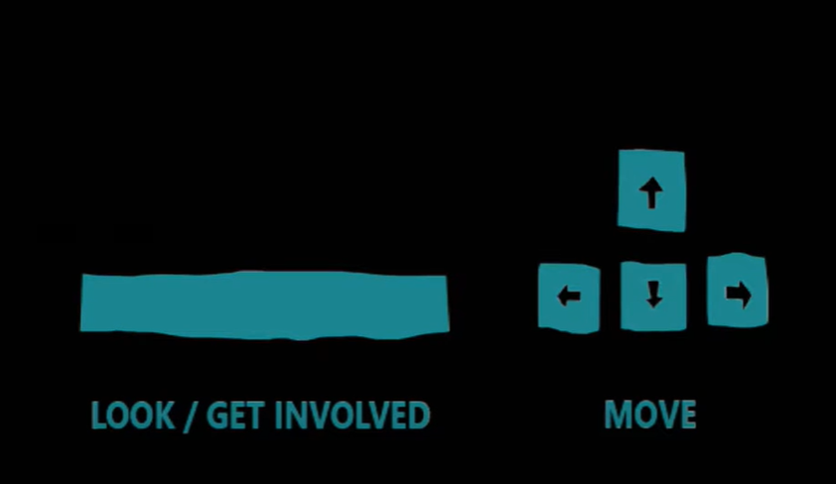

(SPACE OR RETURN TO TAKE ACTION / SHOOT) (WASD OR DIRECTIONAL ARROWS TO MOVE)

**FIRST SCENE (the arrival of the HAMM-3R)**

MARTÍN: Easy, now.

**>> PRESS [LEFT] TO DECELERATE THE CARGO SHIP <<**

(Follows the deceleration gauge mini-game. Depending from how hard we hit the station, there could be 3 – or possibly 4 – outcomes).

1 – SOFT DOCKING:

(small screen shake, clunky sounds effect)

TESS: That was nice and smooth, Captain. I am impressed!

MARTÍN: Smooth is my middle name, Tess.

3R: It is actually LuÍs. Your middle name is LuÍs.

(then go to the NEXT bit of this section)

2 – MID DOCKING:

(mid screen shake, clunky bump effect)

TESS: Ouch! What the heck are you doing?!

MARTÍN: That was not such a bad docking, come on.

3R: An okay docking for someone who is technically a primate, I guess?

(then go to the NEXT bit of this section)

3 – HARD DOCKING:

(heavy screen shake, crash-like sound effect)

TESS: Fuck! Are you trying to knock the station out of orbit?!

MARTÍN: So sorry, Tess! Dios, I don’t know what happened there…

3R: That’s what you get for insisting on **[activity]** while docking, man.

**[activity]** here could be either

* [snacking]
* [watching alien rom-coms]
* [shaving]
* [flossing]
* [texting your daughter]

(then go to the NEXT bit of this section)

4 – [OPTIONAL] CATASTROPHIC DOCKING:

(trigger an explosion, screen shakes, explosion sound)

TESS: Holy…

(screen fades to white, the writing game over appears with the two usual messages:   
  
>> PRESS ANY BUTTON TO START <<

[ESC] TO PAUSE / INFO

)

(then go to the NEXT bit of this section)

**NEXT BIT:**

MARTÍN: Hey! What’s with the sass?

3R: Sass is not part of my programming. It’s more like… A personal preference, I guess.

MARTÍN: Can you have a personal preference when you’re not a person, I wonder?

TESS: Sorry, fellas, but I have a station to run and no time for philobabble.

I’ll take care of the wreck you brought in and wire you the credits, as usual. Anything else?

MARTÍN: Well, we’re scheduled to bring another one in soon. That’s going to be the last of that cluster.

TESS: Then I guess I’ll see you in three weeks or so. Take care out there, both of you! Tess out! [ADD STATIC NOISE]

3R: [Two alternatives]

1) Ouch. That was cold, man!

2) Didn’t you say she was kind of into you or something?

MARTÍN: Just shut up and push us out, will you?

(the HAMM part of the ship pulls out and the camera pans on outer space)

MUSIC + TITLES

Written and Designed by **Stefano Gualeni**

Programming: **Ahmed A. Khalifa**

Art: **Irina Tomova** (3D modelling and textures) & **Daniele Giardini** (concept art and illustrations)

Made possible thanks to **MDIA** [logo] & the **Institute of Digital Games** [logo]

[to be completed once we have all names]

TITLE LOGO: HAMM-3R